Dear Parents/Carers
In school, we often use this maths app, mainly for KS1 children, to practise our mental maths skills – in particular, to help them to recall number facts quickly.
WHITE ROSE 1 MINUTE MATHS
It can be downloaded for free from your usual APP store e.g Google Play

It looks like this ….

We will be asking all children in Y1 and Y2 to spend 5-10 minutes, twice a week, using the app or online site as part of their weekly homework. We will add the focus to the Homework sheet each week.
Thank you for your support!

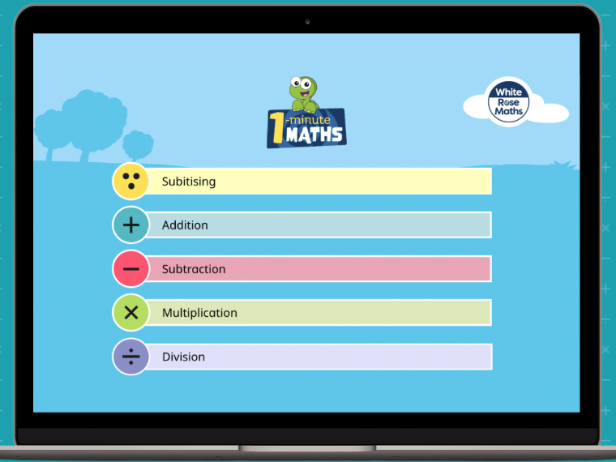

(If you are unable to download the app, there is a web version. Please speak to your child’s class teacher for details.)

Y1 and Y2 Team

